359)Module Intro

Angular universl is tool provided by angular team basically and strongly built into cli which allow you to pre render your angular application on the fly on the server. Whys is interesting. In angular application, inspect the page source. You will see that there actually is not much to be found right.

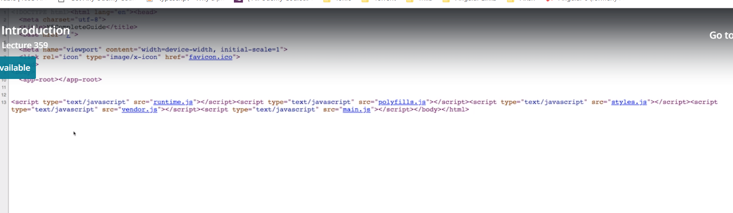

We got script imports and then we have selector of root component. reason for this is anglar is client side framework and our content is rendered in browser after our app is bootstrapped which is done by these script files(imported after app-root selector). now there is nothing wrong with that. But user sees page rendered in browser, search engines see that(html page posted above). So it might be worth exploring a different way of rendering our angular app and angular universal is a tool which basically provides a nice bridge from awesome between awesomeness with angular thatw e have in browser , with this high reactivity, to the pre rendering of pages. So the html that w eget back from server actually is a pre-rendered snapshot of the page and once it runs in the clinet, so in browser, it’s a single page application again sow e want to get best of both words and angular universal can help us with that.